Mrs M Hopton
Parish Clerk/Treasurer
6 Westerdale,
Swanland,
East Riding of Yorkshire HU14 3PY
Tel: 01482 632309
Email: clerk@swanlandparish.org
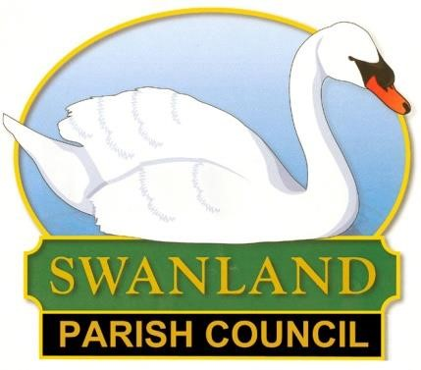

VACANCY FOR A NEW PARISH COUNCILLOR Feel you can make a difference to your community?

The Parish Council is currently looking to co-opt a new member. The next election is due May 2021. Swanland Parish Council is a non-political body and meets at 7pm on the first Monday of the month at the village hall.

Councillors must act within the law and abide by an agreed code of conduct. You must also have
- Been a resident within the parish for 1 year or
- Been a resident within 3 miles of the parish for 1 year or
- Worked in the parish for over 1 year or
- Owned a property within the parish for over 1 year
- Be 18+ (we would love to hear new ideas from all generations in the village)
Although the rules and regulations are important, the role of the councillor is much wider than that. They should

- Represent the interest of the Village
- Respond to the needs and views of the community
- Suggest ideas for better services or improvements
- Look for ways to find out what is important to the community

If you would like to be considered for co-option, please write or email indicating why you would like to be a councillor and what skills/experience you feel you could bring to the role.

If you would like to discuss further what being a councillor entails, please contact the clerk and an informal chat can be arranged with one of our current Councillors or come along to our next meeting.

1

