MAKE A CHANGE BECOME A COUNCILLOR
Are you passionate about your community? Do you want to help make a long-lasting change? Do you have innovative ideas for the council? Do you have concerns about a specific issue and want to do something about it? If this is you, then we need you. We need people from all backgrounds and experiences who reflect their community to put themselves forward for election. Make a change and become a councillor
To be considered to become a Councillor you must -
- Be 18 years of age or over
- Be resident in the parish and on the electoral register (there are some exceptions) Be able to attend regular evening meetings.
- Be interested in local issues and keen to improve the local environment. Understand and be willing to represent the views of the whole community.
- Agree to abide by a Code of Conduct and publicly declare any interests which may conflict with your duties as parish councillor.

Does this sound like you? If so, please contact the clerk for more information or come along and observe a meeting of the parish council, which meets in the Village Hall at 7.00pm on the first Monday in the month. Dates for meetings can be found on the website www.swanlandparishcouncil.gov.uk

Contacts
If you are concerned about anything that affects our Village, please let us know clerk@swanlandparishcouncil.gov.uk or our website aims to allow the Council to communicate more effectively with residents and to provide ways to allow you to contact both Swanland Parish Council and East Riding of Yorkshire County Council. It is kept fully updated with items of local concern including access to current planning applications and how you can register your comments.

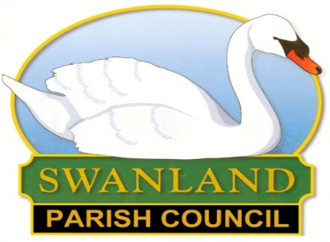 | PARISH COUNCIL  NEWSLETTER SUMMER 2024

LETTER FROM THE CHAIRMAN OF THE PARISH COUNCIL
I write this in the middle of May, just after the very significant Aurora (following an eleven year cycle of major solar activity) visible in our village - and some very warm weather. This is not the only significant event – as this letter comes within the 100th issue of SVA News . This prompted me to look back and the dates that follow are from my own “amateurish” checks and I am sure that the Heritage Centre will have more accurate information!
Swanland Parish Council (or at least the name!) has been around for about 130 years. Electricity arrived in 1929; the water tower in 1931; street lighting in 1954; and the SVA in1989.In the 1951 census there were 1212 residents; in 2001, 3688; and in 2021, 3965.
“The rapid growth of Swanland has put increased pressure on its centre.” “The problem of parking is at its worst at the start and finish of the Primary School day.” Residents expressed concern “about traffic speed at various places in the village, particularly in Main Street, West End and Mill Road”.
This last paragraph could easily refer to comments made at Parish Council meetings over the past year, but in fact come from the Village Design Statement produced about 25 years ago. Some issues just don’t go away and since then the population has increased by around 8% - and probably with greater reliance on cars!
With the Crest Nicholson development, there have been some issues with contractors’ vehicles not using the route specified in the planning approval (along Swanland Dale and up Dale Road) and turning up in Sykes Close, Crowther Way, Westerdale and elsewhere. This seems to be due to the over-reliance on Satnav, poor information to lorry drivers, and a delay in ERYC updating a national database of recommended routes for HGVs (which I certainly didn’t know existed!). The site manager is keen to know of such issues so he can deal with the contractors in an appropriate manner.
There has been significant disruption, especially in the centre of the village, with the installation of telegraph poles as well as underground ducting. Comment has been made about the current “patchwork” look of many footpaths; unfortunately these will stay as they are for some time as repairs/resurfacing are generally only carried out when paths are assessed as dangerous by Highways.
You may have noticed that the temporary signs advising about Algal Bloom in the pond have been replaced by permanent ones. The advice from the Environment Agency is that the Algae, which produce harmful toxins, can be present in inland water even when the water looks clear. As these toxins can kill wild animals, livestock and pets, and can also harm people (producing rashes after skin contact and illnesses if swallowed), please keep yourselves, your children and pets out of the water at all times
The pond and the surrounding area continue to be well maintained by our very keen volunteers in the pond partnership and the gardening group. Regular litter-picking, whether organised by the SVA, or by individuals using their own equipment or that provided by the SVA, has a very major impact on how our village looks. Thank you to all the volunteers who contribute so much to village life!
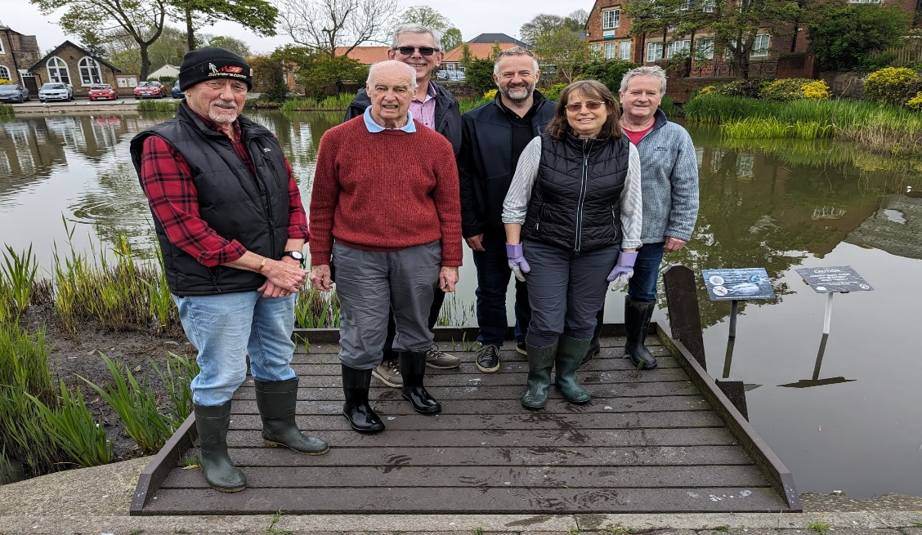
There is currently one vacancy on the Parish Council and if you are interested in this (volunteer) role please get in touch with me or the Clerk (contact details are on the Parish Council website).
Derek Shepherd
WHAT ELSE?

Do you have any ideas for 2024/25 we would love to do even more to enhance our lovely village. Local sponsorship (from both companies and individuals) is always welcome and is very much appreciated. Every bit of extra help we get financially allows us to not only maintain these standards, but also to go that extra mile to maintain and provide wonderful things for our village.

