FATHER CHRISTMAS AT THE POND
This yearly event organised by the Parish Council will take place on Monday 23rd December. Organisation for this event has already commenced obtaining Road Closure permits and licences for the pond lights which have been put up for many many years by the May family along with numerous other helpers.
Help on the day is always welcome a few years ago the event was touch and go due to the icy pond. Luckily with the support of councillors, previous councillors and the clerk breaking the ice in the pond for most of the day ensured this memorable event took place.
Unfortunately, one of our main helpers for this event is no longer with us so please let us know if you can spare a few hours. Many of you have attended this event for many years and are now still coming along with not only your children but grandchildren.
Contacts
If you are concerned about anything that affects our Village, please let us know clerk@swanlandparishcouncil.gov.uk or our website aims to allow the Council to communicate more effectively with residents and to provide ways to allow you to contact both Swanland Parish Council and East Riding of Yorkshire County Council. It is kept fully updated with items of local interest including access to current planning applications and how you can register your comments.

WHAT ELSE?
Do you have any ideas for 2024/25 we would love to do even more to enhance our lovely village. Local sponsorship (from both companies and individuals) is always welcome and is very much appreciated.

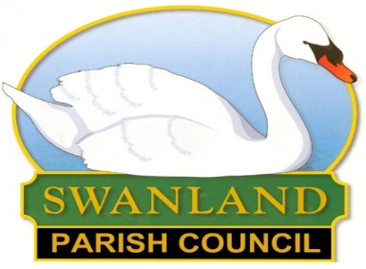 | PARISH COUNCIL  NEWSLETTER AUTUMN 2024

LETTER FROM THE CHAIRMAN OF THE PARISH COUNCIL
I write this towards the end of September, I think I have to accept that summer is (almost) over and that shorts (for any who actually started wearing them!) should soon go back in the wardrobe for another year.
We are extremely fortunate in the village that there are quite a number of different groups of volunteers working across the village to look after and improve different areas – litter picking, pond maintenance, flower group, playing fields, village hall to name just a few (these, and others, may well be mentioned elsewhere in the SVA newsletter).
If you have any capacity to do more with your limited time than you already do, there might be a group looking for you!
Just to (not) mention an event later in the year, we are very hopeful that a certain person will be visiting the village and crossing the pond the Monday evening before his busiest night.
As always, any collection taken around the pond at the event will all go to local charities.
I think the number of construction vehicles “getting lost” on their way to the Crest Nicholson development has decreased over time.
I expect that some lorry drivers delivering quite properly to existing addresses within Swanland have been incorrectly challenged as well!
An updated version of the East Riding Local Plan is being consulted on after various amendments “suggested” by the Planning Inspectorate.
This covers the period to 2039 (subject as always to changes in planning policy) and contains additional locations assessed as suitable for housing development.
As things stand, it is a relief to see that there are no such areas around Swanland.
Nevertheless, there is nothing to stop residents responding to the consultation (via the ERYC website) to say they are relieved that this is the case.
I believe a copy of the documents can be viewed at the library – but I would check before you made a special visit!
Last time I mentioned that there was one vacancy on the Parish Council. This has now been filled.
Don’t worry if you were interested in this (volunteer) role as, when the next election come round in a few years, a review of all Parish and Town Councils has recommended increasing our number by three!
Please do get in touch with me or the Clerk (contact details are on the Parish Council website) if interested.
Derek Shepherd

Hedges and Overhanging Trees
Over the summer, Swanland Parish Council asked some residents if they could cut back their hedges or overhanging branches due to concerns about hedges/overhanging branches encroaching onto paths and roads. Thank you to all residents who responded so readily when asked to do so.
Cutting back hedges and overhanging branches really helps the local community both in terms of making the area look neat and tidy as well as helping people make use of roads and footpaths more easily and safely.
Please be aware you should only proceed with cutting hedges/trees after checking you will not harm nesting birds by doing so.
If you are unsure as to who is responsibility it is to maintaining overgrown hedges/trees you can report this via Trees, hedges and grass cutting (eastriding.gov.uk) For example the overgrown hedge in front of the electricity substation on West End was reported and resolved in a timely manner.
We would like to thank Community payback Scheme for the clearance work carried out Dale Road and Westella Road footpaths. These works were conducted over the summer on hot days and many residents supplied cold drinks and ice creams which were very much appreciated.
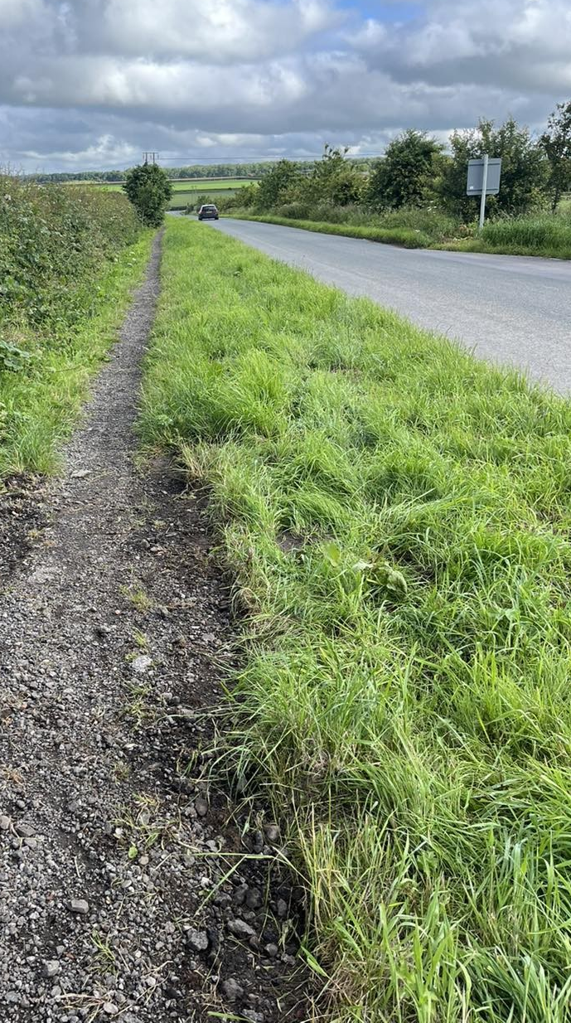
Pot holes and faulty street lights can also be easily reported via Potholes (eastriding.gov.uk) or Street lights and traffic lights (eastriding.gov.uk) These links can often be found quicker on a google search!

