WHAT TO EXPECT AT A PARISH COUNCIL MEETING?
Please come along to one of our meeting all the dates are on our notice board(located in front of the Swan and Cygnet Pub) and you will also be able to find them on our website http://www.swanlandparishcouncil.gov.uk/
Prior to the start of an ordinary Parish Council meeting thirty minutes shall be set aside for members of the public (residents of Swanland) to speak on any matter of concern whether or not that matter is an agenda item. All members and the Clerk shall be present for this thirty-minute session.
Contacts
If you are concerned about anything that affects our Village, please let us know. http://www.swanlandparishcouncil.gov.uk/
clerk@swnlandparishcouncil.gov.uk
The website aims to allow the Council to communicate more effectively with residents and to provide ways to allow you to contact both Swanland Parish Council and East Riding of Yorkshire County Council. It is kept fully updated with items of local concern including access to current planning applications and how you can register your comments.
WHAT ELSE?
Do you have any ideas for 2023 we would love to do even more to enhance our lovely village. Local sponsorship (from both companies and individuals) is always welcome and is very much appreciated. Every bit of extra help we get financially allows us to not only maintain these standards, but also to go that extra mile to maintain and provide wonderful things for our village.

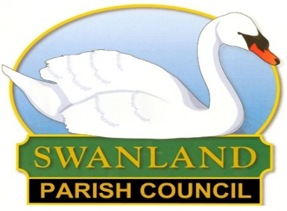 | NEWSLETTER SUMMER 2023  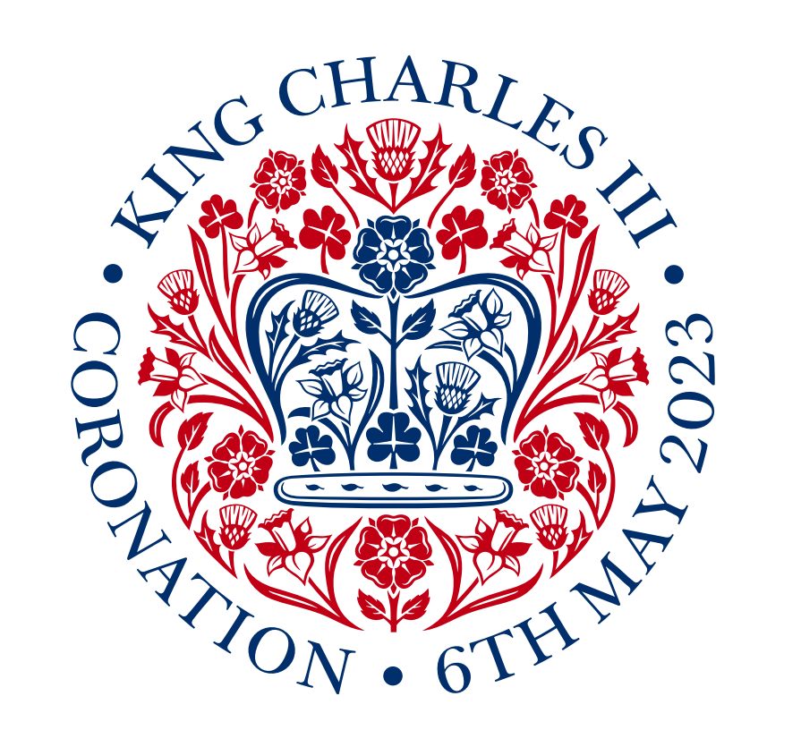

LETTER FROM THE CHAIRMAN –
I write this in the middle of April and so the Coronation is several weeks away – and by the time you read this, it will be a few weeks in the past!
I just hope that the long weekend went well – in Swanland as well as in London and the rest of the country.
Flags, bunting and roundels with the official emblem would have been put up, with a particular focus around the pond, and I am sure many will have celebrated in different ways – including by taking part in the volunteering day on the Monday.
You will also be reading this after the local elections have taken – for Parish Councillors and for ERYC Ward Councillors.
I do know the result of the election for Parish Councillors but only because there were insufficient candidates to fill all the posts, let alone enough to lead to a vote.
There will be one vacancy on the Parish Council and so we will hope to fill that by co-option in the weeks/months ahead.
Please do consider if you could take on this voluntary (and unglamorous!) role in supporting village life. If you are interested, please get in touch with me or the Clerk (contact details are on the Parish Council website).
Whoever were successful in becoming our Ward Councillors, I hope that they will be as supportive a team to our village as Vanessa Walker and Julie Abraham were for many years. I certainly do, and will continue to do, miss their support, knowledge and expertise.
There has been concern about parking outside the school (just like at most other schools) for many years from parents and other road users. A small minority of road users fail to show the consideration, patience and care that most would expect (and which the Highway Code encourages).
After recently meeting with someone from Highways outside the school and clarifying a number of issues, I understand various changes are being reviewed and then a plan will go out for consultation (and may already have done so when you read this).
Another reminder that only pedestrian access to the playing fields is possible along Wold View – car park access is via Blossom Close.
Please do not park on Wold View and use that pedestrian gate as it often blocks Wold View (which is narrow) and more importantly negates the safety benefits of separating foot and vehicle access.
We are endeavouring to get a sign placed (and Google maps to update their “routing”!).
Can I wish you all the very best for, what I understand will be called, the new Carolean Era (from the Latin for Charles, Carolus) – of course that might have changed when you read this!
Derek Shepherd
East Yorkshire Service Service 150
This circular service operates Tuesday and Thursdays only, connecting Swanland and North Ferriby with Hessle Square, enabling connections to other bus routes. 150 goes onto Sainsbury’s and Homebase and returns via North Ferriby to Melton Business Park and then back up to Swanland. The 11.30am loop [11.45 @ Swanland] allows sufficient time [about 40 mins] to shop in Sainsbury’s, whilst driver has their lunchbreak.
There’s a timetable on bus stops around the village including West Leys Road and the Bus Shelter by the Swan and Cygnet. The 150 initial trial was extended last year, now the 153 service from the centre of Hull terminates at the pond, with no daily bus connection to North Ferriby. The service is funded by East Riding of Yorkshire Council and sadly the old “Use It or Lose It” adage may be the case. East Yorkshire buses are displaying the “Sainsbury” supermarket destination on newer buses, but some of the older fleet, does not yet have this facility
Concessionary passholders travel free.
Gardening
Hedges: Please don’t let your hedges obstruct the paths during the summer. Obstruction could cause someone to step into the road with oncoming vehicles or be injured by low hanging branches. If anyone notices any obstructions whilst out walking, please let the Clerk know.
Allotments: Most of the plots are being kept in good order. We have 8 residents currently on the waiting list. We hope all our tenants have a good year.

